**DLB Lab -2**

Tasks

Roll no: 23K-2001

BCS 2-J

**Exercise # 01: Y = A+B’**

|  |  |  |
| --- | --- | --- |
| ***INPUT (A)*** | ***INPUT (B)*** | ***OUTPUT (Y)*** |
| 0 | 0 | 1 |
| 0 | 1 | 0 |
| 1 | 0 | 1 |
| 1 | 1 | 1 |

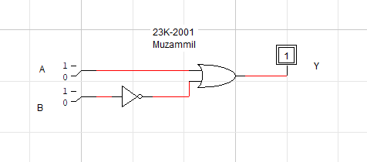

**Exercise #02: F = X’Y+XZ**

|  |  |  |  |
| --- | --- | --- | --- |
| ***Input (X)*** | ***Input (Y)*** | ***Input (Z)*** | ***Output (F)*** |
| 0 | 0 | 0 | 0 |
| 0 | 0 | 1 | 0 |
| 0 | 1 | 0 | 1 |
| 0 | 1 | 1 | 1 |
| 1 | 0 | 0 | 0 |
| 1 | 0 | 1 | 1 |
| 1 | 1 | 0 | 0 |
| 1 | 1 | 1 | 1 |

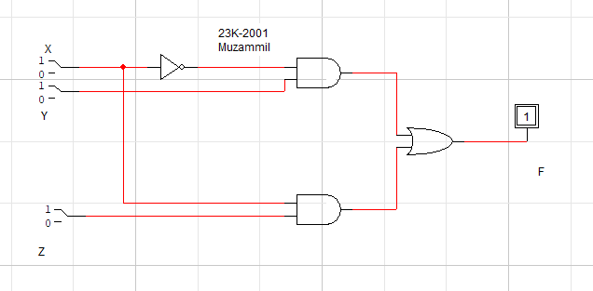

**Exercise #03: F = ((AB + CD)’ + B’)(C’)**

|  |  |  |  |  |
| --- | --- | --- | --- | --- |
| **Input (A)** | **Input (B)** | **Input (C)** | **Input (D)** | **Output (F)** |
| **0** | **0** | **0** | **0** | **1** |
| **0** | **0** | **0** | **1** | **1** |
| **0** | **0** | **1** | **0** | **0** |
| **0** | **0** | **1** | **1** | **0** |
| **0** | **1** | **0** | **0** | **1** |
| **0** | **1** | **0** | **1** | **1** |
| **0** | **1** | **1** | **0** | **0** |
| **0** | **1** | **1** | **1** | **0** |
| **1** | **0** | **0** | **0** | **1** |
| **1** | **0** | **0** | **1** | **1** |
| **1** | **0** | **1** | **0** | **0** |
| **1** | **0** | **1** | **1** | **0** |
| **1** | **1** | **0** | **0** | **0** |
| **1** | **1** | **0** | **1** | **0** |
| **1** | **1** | **1** | **0** | **0** |
| **1** | **1** | **1** | **1** | **0** |

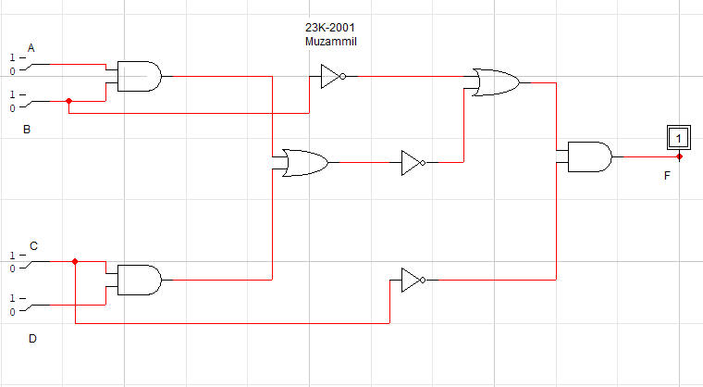

**Exercise #04:**

1. **F = A+A’B**

|  |  |  |
| --- | --- | --- |
| ***Input A*** | ***Input B*** | ***Output F*** |
| 0 | 0 | 0 |
| 0 | 1 | 1 |
| 1 | 0 | 1 |
| 1 | 1 | 1 |

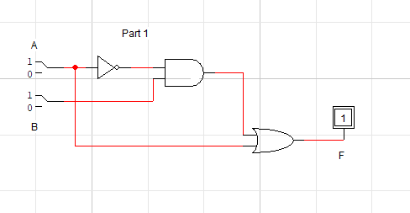

1. **F = (A+B)(A+C)**

|  |  |  |  |
| --- | --- | --- | --- |
| ***Input A*** | ***Input B*** | ***Input C*** | ***Output F*** |
| 0 | 0 | 0 | 0 |
| 0 | 0 | 1 | 0 |
| 0 | 1 | 0 | 0 |
| 0 | 1 | 1 | 1 |
| 1 | 0 | 0 | 1 |
| 1 | 0 | 1 | 1 |
| 1 | 1 | 0 | 1 |
| 1 | 1 | 1 | 1 |

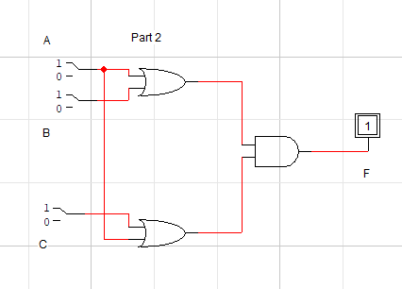

1. **F = A(B+CD)**

**3. F = A(B+CD)**

|  |  |  |  |  |
| --- | --- | --- | --- | --- |
| ***Input A*** | ***Input B*** | ***Input C*** | ***Input D*** | ***Output F*** |
| 0 | 0 | 0 | 0 | 0 |
| 0 | 0 | 0 | 1 | 0 |
| 0 | 0 | 1 | 0 | 0 |
| 0 | 0 | 1 | 1 | 0 |
| 0 | 1 | 0 | 0 | 0 |
| 0 | 1 | 0 | 1 | 0 |
| 0 | 1 | 1 | 0 | 0 |
| 0 | 1 | 1 | 1 | 0 |
| 1 | 0 | 0 | 0 | 0 |
| 1 | 0 | 0 | 1 | 0 |
| 1 | 0 | 1 | 0 | 0 |
| 1 | 0 | 1 | 1 | 1 |
| 1 | 1 | 0 | 0 | 1 |
| 1 | 1 | 0 | 1 | 1 |
| 1 | 1 | 1 | 0 | 1 |
| 1 | 1 | 1 | 1 | 1 |

1. **F = AB + A(B+C)+(B+C)**

|  |  |  |  |
| --- | --- | --- | --- |
| ***Input A*** | ***Input B*** | ***Input C*** | ***Output F*** |
| 0 | 0 | 0 | 0 |
| 0 | 0 | 1 | 1 |
| 0 | 1 | 0 | 1 |
| 0 | 1 | 1 | 1 |
| 1 | 0 | 0 | 0 |
| 1 | 0 | 1 | 1 |
| 1 | 1 | 0 | 1 |
| 1 | 1 | 1 | 1 |

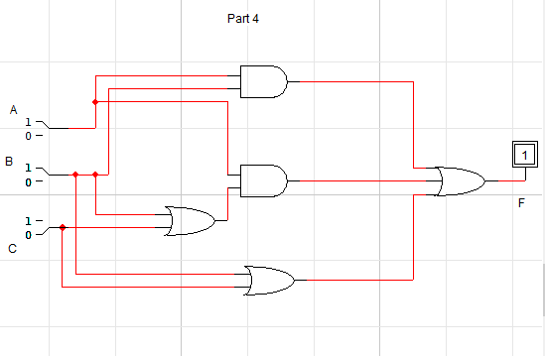

1. **F = X(YZ) + X’Y + (XY)Z’**

|  |  |  |  |
| --- | --- | --- | --- |
| ***Input X*** | ***Input Y*** | ***Input Z*** | ***Output F*** |
| 0 | 0 | 0 | 0 |
| 0 | 0 | 1 | 0 |
| 0 | 1 | 0 | 1 |
| 0 | 1 | 1 | 1 |
| 1 | 0 | 0 | 0 |
| 1 | 0 | 1 | 0 |
| 1 | 1 | 0 | 1 |
| 1 | 1 | 1 | 1 |

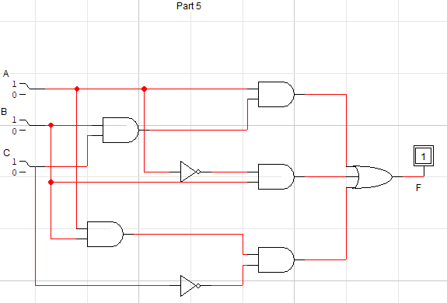

1. **F = B’C + AC’**

|  |  |  |  |
| --- | --- | --- | --- |
| ***Input A*** | ***Input B*** | ***Input C*** | ***Output F*** |
| 0 | 0 | 0 | 0 |
| 0 | 0 | 1 | 1 |
| 0 | 1 | 0 | 0 |
| 0 | 1 | 1 | 0 |
| 1 | 0 | 0 | 1 |
| 1 | 0 | 1 | 1 |
| 1 | 1 | 0 | 1 |
| 1 | 1 | 1 | 0 |

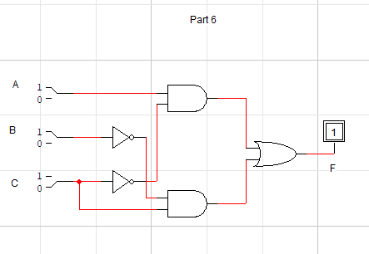

1. **F = X’ + Y’Z**

|  |  |  |  |
| --- | --- | --- | --- |
| ***Input X*** | ***Input Y*** | ***Input Z*** | ***Output F*** |
| 0 | 0 | 0 | 1 |
| 0 | 0 | 1 | 1 |
| 0 | 1 | 0 | 1 |
| 0 | 1 | 1 | 1 |
| 1 | 0 | 0 | 0 |
| 1 | 0 | 1 | 1 |
| 1 | 1 | 0 | 0 |
| 1 | 1 | 1 | 0 |

